Click
First *
ª ^{aFirst}
^{b} ^{bSecond}

Abstract
Click

Keywords: Aaaa, bbbb, cccc, dddd
- Introduction
(10 pt) Here introduce the paper, and put a nomenclature if necessary, in a box with the same font size as the rest of the paper. The paragraphs continue from here and are only separated by headings, subheadings, images and formulae. The section headings are arranged by numbers, bold and 10 pt. Here follows further instructions for authors
  - Structure
Files should be in MS Word format only and should be formatted for direct printing. Figures and tables should be embedded and not supplied separately. Please make sure that you use as much as possible normal fonts in your documents. Special fonts, such as fonts used in the Far East (Japanese, Chinese, Korean, etc.) may cause problems during processing. To avoid unnecessary errors you are strongly advised to use the ‘spellchecker’ function of MS Word. Follow this order when typing manuscripts: Title, Authors, Affiliations, Abstract, Keywords, Main text (including figures and tables), Acknowledgements, References, Appendix. Collate acknowledgements in a separate section at the end of the article and do not include them on the title page, as a footnote to the title or otherwise.
Bulleted lists may be included and should look like this:
- First point
- Second point
- And so on
Please do not alter the formatting and style layouts which have been set up in this template document. As indicated in the template, papers should be prepared in single column format suitable for direct printing onto A4 paper (192 mm×262 mm). Do not number pages on the front, as page numbers will be added separately for the preprints and the Journal. All the required style templates are provided in this document; please follow them in preparing your manuscript.
  - Tables
Table 1. An example of a table
An example of a column heading | Column A (t) | Column B (T)
And an entry | 1 | 2
And another entry | 3 | 4
And another entry | 5 | 6
  - Construction of references
References should be listed at the end of the paper, and numbered in the order of their appearance in the text. Authors should ensure that every reference in the text appears in the list of references and vice versa. Indicate references by numbers in square brackets [??] in the text. The actual authors can be referred to, but the reference number(s) must always be given.
Some examples of how your references should be listed are given at the end of this template in the ‘References’ section which will allow you to assemble your reference list according to the correct format and font size. There is a shortened form for more than 6 authors the first 6 should be listed followed by “et al.”
  - Section headings
Section headings should be left justified, with the first letter capitalized and numbered consecutively, starting with the Introduction. Sub-section headings should be in capital and lower-case italic letters, numbered 1.1, 1.2, etc, and left justified.
  - General guidelines for the preparation of your text
Avoid hyphenation at the end of a line. Symbols denoting vectors and matrices should be indicated in bold type. Scalar variable names should normally be expressed using italics. Weights and measures should be expressed in SI units.
  - Footnotes
Footnotes should be avoided. Necessary “footnotes” should be composed directly in the text, instead of footnote style.
- Author Artwork
All figures should be numbered with Arabic numerals (1,2,...n). All photographs, schemas, graphs and diagrams are to be referred to as figures. Line drawings should be good quality scans or true electronic output. Low-quality scans are not acceptable. Figures must be embedded into the text and not supplied separately. Lettering and symbols should be clearly defined either in the caption or in a legend provided as part of the figure. Figures should be placed at the top or bottom of a page wherever possible, as close as possible to the first reference to them in the paper.
The figure number and caption should be typed below the illustration in 9pt and left justified. However, if two images fit next to each other, these may be placed next to each other to save space, see Fig. 1. They must be numbered consecutively, all figures, and all tables respectively.
Figure axis labels are often a source of incompleteness. All coordinate graphs should have the axis labels: physical quantity with unit in parentheses, as shown in Fig. 1.
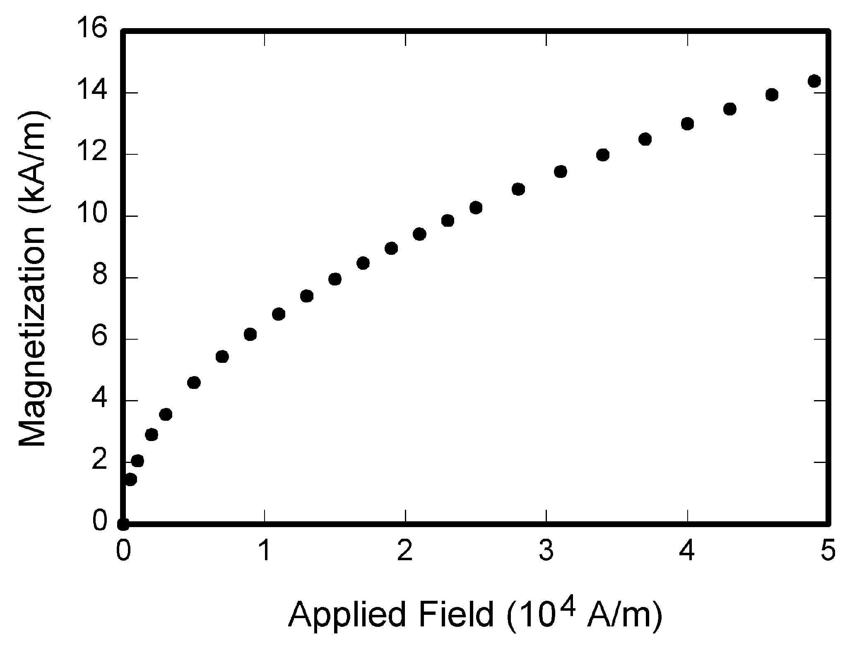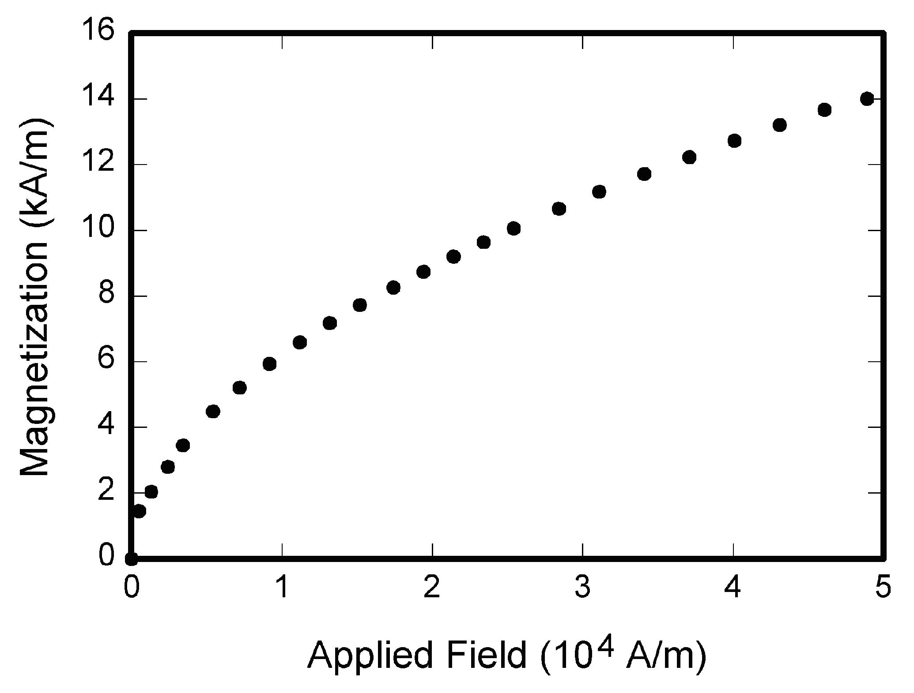
(a) (b)
Fig. 1. Magnetization as a function of applied field: (a) condition 1and (b) condition 2.
Equations and formulae should be typed and numbered consecutively with Arabic numerals in parentheses on the right hand side of the page (if referred to explicitly in the text),
(1)
It is advised to create equations or variables by the MathType. Size setting of equations is as follows:
Full 10pt;
Subscript 6pt
Sub-subscript 4.5pt
Symbol 12pt
Sub-symbol 8pt
- Copyright
All authors must sign the Transfer of Copyright agreement before the article can be published. This transfer agreement enables ETP (Engineering and Technology Publishing) to protect the copyrighted material for the authors, but does not relinquish the authors' proprietary rights. The copyright transfer covers the exclusive rights to reproduce and distribute the article, including reprints, photographic reproductions, microfilm or any other reproductions of similar nature and translations. Authors are responsible for obtaining from the copyright holder permission to reproduce any figures for which copyright exists.
Appendix A: An example appendix
Authors including an appendix section should do so after References section. Multiple appendices should all have headings in the style used above. They will automatically be ordered A, B, C etc.
  - Example of a sub-heading within an appendix
There is also the option to include a subheading within the Appendix if you wish.
Conflict of Interest
Please declare whether or not the submitted work was carried out with a conflict of interest. If yes, please state any personal, professional or financial relationships that could potentially be construed as a conflict of interest. If no, please add "The authors declare no conflict of interest".
Author Contributions
Please state each author's contribution to this work, it can be up to several sentences long and should briefly describe the tasks of individual authors. e.g., A,B concuted the research; C,D analyzed the data; A,B wrote the paper; ...; all authors had approved the final version.
Acknowledgements
These and the Reference headings are in bold but have no numbers. Text below continues as normal.
References
Journal Paper Format:
[1] Lukic SM, Mulhall P, Emadi A. Energy autonomous solar/battery auto rickshaw. Journal of Asian Electric Vehicles, 2008; 6(2):1135-1143.
Book Format:
[2] Strunk Jr W, White EB. The Elements of Style. 3rd ed. New York: Macmillan; 1979.
Paper (within a Book with Editors) Format:
[3] Mettam GR, Adams LB. How to prepare an electronic version of your article. In: Jones BS, Smith RZ, editors. Introduction to the Electronic Age, New York: E-Publishing Inc; 1999:281–304.
Conference Paper with pages Format:
[4] Heydt GT, Kezunovic M, Sauer PW, Bose A, McCalley JD, Singh C, Jewell WT, Ray DJ, Vittal V. Professional resources to implement the smart grid. In: Proc. of North American Power Symposium, 2009:1–8.
Conference Paper without pages Format:
[5] Sharma A, Navda V, Ramjee R, Padmanabhan VN, Belding EM. Cool-tether: energy efficient on-the-fly WiFi hot-spots using mobile phones. Presented at: 2009 IEEE CoNEXT.
Web Material Format:
[6] Wright J. (November 2009). Killerbee: practical zigbee exploitation framework. [Online]. Available: http://www.willhackforsushi.com/presentations/toorcon11-wright.pdf
Thesis or Dissertation Format
[7] Williams J. Narrow-band analyzer. PhD dissertation. Department of Electrical Engineering, Harvard University. Cambridge, MA; 1993.
[8] Kawasaki N. .Parametric study of thermal and chemical nonequilibrium nozzle flow. MS thesis. Department of Electronic Engineering, Osaka University. Osaka, Japan; 1993.
Research Report Format
[9] Pallotti E, Mangiatordi F. Smart grid cyber security requirements. Research report. Electronics Deprtment, Roma Tre University, 2011.
Submitted Paper Format:
[10] Baig ZA, Saif A. Device Implant attack detection for the smart grid infrastructure. Submitted to Smart Grid Communications (SmartGridComm), 2012.
Standards Format
[11] Quality of Electric Energy Supply Harmonics in Public Supply Network. GB/T 14549-93 (1993).

Copyright © 2020 by the authors. This is an open access article distributed under the Creative Commons Attribution License (CC BY-NC-ND 4.0), which permits use, distribution and reproduction in any medium, provided that the article is properly cited, the use is non-commercial and no modifications or adaptations are made.

* Manuscript received MM DD, 2013; revised MM DD, 2013. Corresponding author. Tel.: +0-000-000-0000; E-mail address: author@institute.xxx.

